 |  | Ripley Infant School  Kirk Close  Ripley  Derbyshire DE5 3RY
Telephone: | 01773 743354 |  | Headteacher: Mrs P. Doleman BEd Hons, MA(Ed)
Fax: | 01773 512638
19th March 2020

Dear Parents/Carers,

Re: Coronavirus update – school closure to most pupils

Following on from my last update, I’m now writing to let you know that we have now been instructed to close the school to almost all children after this Friday until further notice.
As advised by the government, we will do all we can to stay open for the children of key workers (e.g. NHS staff, police, others in frontline services) and children with certain needs.
We’ll be in contact with anyone this applies to directly.
All other children will need to stay at home, so we ask that you do not send your child into school from Monday onwards.
Please note that this is a national closure – as you may have heard in the news – so while it is a challenging situation, we are not alone. We’ll re-open fully as soon as we can and will let you know when this is by text, school app and on our website.

What we’ll continue doing while your child is at home
Your child’s learning is of course important to us, so we’ll continue to help your child to learn.
Information about this was contained in my letter yesterday.
If your child usually receives free school meals we will also be in touch with more information about how we will continue to provide this, with support from a scheme that the government has just announced.

What we won’t be able to go ahead with
School trips
Breakfast or after-school clubs
Whole school events
SATs or Phonic Screening checks

This is as much as we know right now and we appreciate your continued patience with as we deal with this ever-changing situation. We understand that this latest news will have an impact on you and your family and it’s far from ideal, but we’ll continue to keep in touch with any updates as the situation develops.
If you want to get in touch to share any concerns, please don’t hesitate to do so via email – info@ripley-inf.derbyshire.sch.uk or headtecher@ripley-inf.derbyshire.sch.uk .

And remember: if you or your child feels ill and you want to know what to do next, please use NHS 111 online.
Thank you again for your continued support, and we will be in touch with more information when we can.

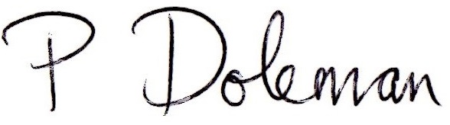
Mrs Paula Doleman
Headteacher

