 |  | Ripley Infant School  Kirk Close  Ripley  Derbyshire DE5 3RY
Telephone: | 01773 743354 |  | Headteacher: Mrs P. Doleman BEd Hons, MA(Ed)
Fax: | 01773 512638
 |  |  | 14.07.20

Dear Parents/Carers,

In line with government guidance and following a thorough risk assessment we intend to reopen school to all pupils on Thursday 3rd September 2020. It has been made clear by the government that they expect all children to attend.

In order to follow government guidelines and to minimise risk as much as possible please read the following information carefully.

Children will be in class bubbles, except for Reception who will be in a year group bubble (specific information for new starters will be sent separately) and will not be mixing with other children as far as is possible. Each bubble will have their own teacher, Teaching assistant(s) and Midday supervisor. There will be no whole school assemblies in the hall and for the first half term there will also be no after school clubs.

Key Stage 1 classrooms have been organised with children seated in pairs facing forwards and children will have access to their own stationary and all shared materials will be cleaned between use. Children will only need to bring a coat, snack, and water bottle.

There will be a staggered start and end to the day. All children will be dropped off and picked up at the pedestrian gate and met by myself and Mrs Skermer. It is very important that you are on time to avoid mixing with the next bubble. If your child has a sibling in another bubble they should come at the same time as the first child is due in school but then join their own bubble. They will enter their own classroom through the external doors.
The timings for beginning and end of the day are as follows:

Start time | Class | Pick up time
8.45 | Starlings | 2.45
8.55 | Skylarks | 2.55
9.05 | Ravens | 3.05
9.15 | Woodpeckers | 3.15

Children should come to school in normal uniform. The government guidance indicates that there is no need to clean this more than normal or use any additional cleaning methods.
On PE days children should come to school in their PE kit and they will remain in it all day. Staff will inform you of PE days in September.

Lunches can be provided free of charge from the school kitchen. These will be hot ‘Grab and Go’ bags which will be eaten in classrooms (a menu will be available to view on our website). Should you wish your child can bring their own packed lunch.

In order to observe social distancing and limit social interaction, parents will not be coming on to school premises without prior arrangement. This will be the arrangement for the Autumn term but will be reviewed following the release of any further guidance. We ask that if you have any concerns or queries you contact school via phone or email.

Of course these arrangements are subject to change should new guidance be issued by the government and should this be the case we will contact you before the start of term.

Thank you for your support and understanding throughout this time and we look forward to seeing you in September.

Kind regards

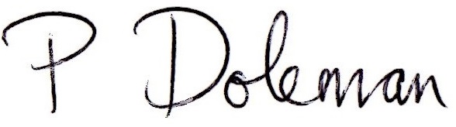

Mrs Paula Doleman
Headteacher

