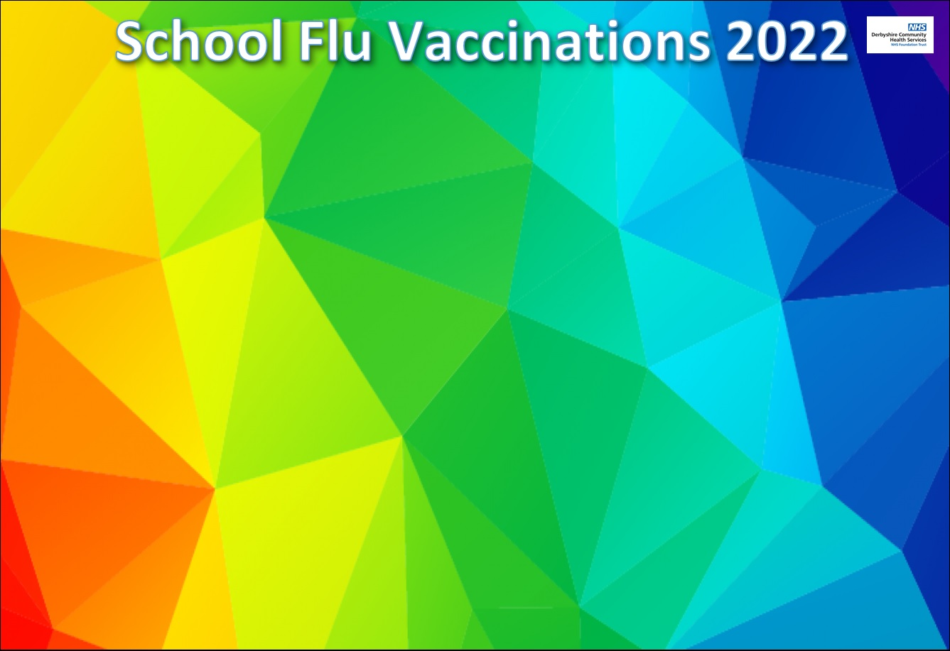

To complete the consent form for your child to receive the flu vaccination, click the link below. One form for each child.

[**https://www.derbyshireandcityimms.co.uk/Forms/Flu**](https://www.derbyshireandcityimms.co.uk/Forms/Flu)

School name: **Ripley Infant School**

School code: **DD112612**

Date in school: **17 October 2022**

[Flu Information Leaflet](https://assets.publishing.service.gov.uk/government/uploads/system/uploads/attachment_data/file/1087835/UKHSA-12388-protecting-your-child-against-flu-2022-2023.pdf)

**Repton:** 01283 707178 **Clay Cross:** 01246 252953

[DCHST.immunisationteam@nhs.net](mailto:DCHST.immunisationteam@nhs.net)

[www.derbyshirefamilyhealthservice.nhs.uk](https://www.derbyshirefamilyhealthservice.nhs.uk/our-services/5-10-years/school-age-immunisations)

